MOHAMED M.A. MOUSTAFA MBBCh, MSc.
CURRICULUM VITAE
2019

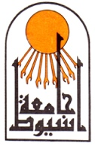

Assiut University

Faculty of Medicine

Dept. of Orthopedics

And Traumatology

CURRICULUM VITAE

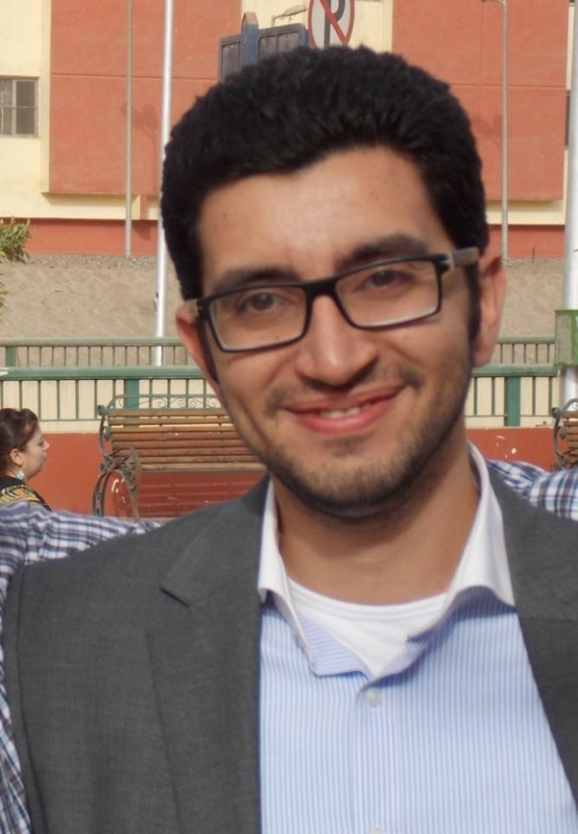

Mohamed M. Alaa El Din Moustafa
Specialist of Orthopedics surgery and traumatology
Assistant lecturer of Orthopedics and traumatology,
Assiut University Hospitals and School of Medicine
Assiut, Egypt
AOtrauma regional faculty
Tel: Home (+2088) 2327279, (+2088) 2317279
Office (+2088)2413345, (+2088) 2413343
Mobile:(+20) 1096967747
E-Mail: m.m.a.abdelaziz@gmail.com
mohamed.m.alaa@aun.edu.eg
Last update September, 2019.

Personal details

Surname | Moustafa
Forenames | Mohamed Moustafa Alaa
Date &place of Birth | 17/11/1984,  Assiut, Egypt
Address  (home Address) | 57 el-Hussai tower sawra st., 4th floor, above national motors showroom.  71111
(office Address) | Department of Orthopaedics and Traumatology  Assiut University Hospitals , Assiut , Egypt  71526
Language Proficiency | Arabic(native)  English  French(4ys in school)  German
Email: | m.m.a.abdelaziz@gmail.com  Mohamed.m.alaa@aun.edu.eg
Marital Status | Married
Nationality | Egyptian
Military status | exempted

Qualifications

April 2018 | M.D. exams (grade: very good)
June 2016 | AO Trauma, middle East regional faculty
April 2017 | Partial fulfilment of MD degree  Passed the final examinations(Research Methodology, Biostatistics and Forensic Medicine)
April 2012 | M.Sc. in Orthopedics surgery and Traumatology Faculty of Medicine, Assiut University, Egypt. (With general grade of Very Good).
September 2007 | M.B.B.Ch in Surgery and Medicine, Faculty of Medicine, Assiut University, Egypt. (With general grade of Excellent with honor).

Appointment
November- December  2018 | AOTRAUMA fellowship in tubingen Germany
October 2015-March 2016 | SICOT assiut-wurzburg arthroplasty fellowship in konig-ludwid-haus hospital Wurzburg, germany
Currently  (July 2012 till now) | Assistant Lecturer in orthopaedics and traumatology, Assiut University Hospitals, Assiut, Egypt.  Subspeciality: arthroplasty unit fellow since 2014)
March 2012-july 2012 | Demonstrator in orthopaedics and traumatology, Assiut University Hospitals, Assiut, Egypt.
March 2009 - February 2012 | Resident in orthopaedics and traumatology Department, Assiut University Hospitals, Assiut, Egypt. (registrar level for 36 months)
Mach 2008 -February 2009 | House Officer, Assiut University Hospital, Assiut, Egypt.

Teaching activites and Experience

August 2012 till now | Assistant Lecturer in Orthopedics and trauma surgery, Assiut University Hospitals, Assiut, Egypt.  Responsibility was assumed for teaching both house officers and postgraduate students. Teaching to undergraduate medical students was divided into small groups ward round teaching sessions, outpatient clinic teaching sessions and primary health care unit teaching sessions. Teaching to postgraduates at house officer level was focused on tutorials and operative demonstration as well as supervision of operative sessions by juniors. Additional duties included supervision and assistance of MSc students in the conduct of research work.
8-10 dec 2012 | I passed the training program of “conference organization” from the  FLDC(Faculty and Leadership Development Centre) – Assiut University.
4-6 june 2012 | I passed the training program of “Student Evaluation” from the  FLDC(Faculty and Leadership Development Centre) – Assiut University.

- I have passed the following training programs from the FLDC(Faculty and Leadership Development Centre) – Assiut University:

  - International Publishing of Research (13-15 July 2013)
  - Research methodology (28-30 may 2012)

- Winning the AO Trauma Middle East Research Grants (2012)
“Study of incidence of osteoporosis among cases of proximal femoral fractures in upper Egypt.”

Participate in development and data analysis of arthroplasty unit registry
In assiut university hospitals
AOspine mentorship program award 2015
PAM study participant
SICOT trainee day award in 68th Annual International Congress of the Egyptian Orthopedic Association, Cairo, Egypt. 2016

AO trauma Basic principles course | Participant | Prauge | 9/2011
AO trauma Advanced principles | Participant | cairo | 2012
AO trauma Basic principles | instructor | cairo | 2013
AO trauma ftp | Participant | cairo | 2014
AO trauma Basic principles course orp | faculty | cairo | 2014
AO trauma Basic principles course orp | faculty | cairo | 2015
AO trauma Faculty education program | paricipant | dubai | 2016
AO trauma Basic principles course orp | faculty | cairo | 2016
AO trauma Basic principles course orp | faculty | cairo | 2017
AOspine mentorship program | participant | assiut | 2016
AOspine mentorship program | participant | assiut | 2017
AO trauma Basic principles course | faculty | assiut | 2018
AO trauma Advanced principles | faculty | cairo | 2018
AO trauma Basic principles course | faculty | assiut | 2019
AO Trauma masters course, lower limb | participant | cairo | 2019

Training Experience and Duties

Surgical Experience:

Trauma:

Different techniques of ORIF of several fracture patterns: (proximal H., Shaft humerus, distal humerus, olecranon, Radius and ulna, distal radius, neck femur, shaft femur, distal femur, tibial plateau, shaft tibia, pilon fr., ankle fr. Dislocation).

Hemi-arthroplasty of the hip joint

Repair of tendon injuries and N. injury at different zones (fresh cases).

Fixation of the Dorso-lumbar spine using the TPSF, decompression of the spinal cord and repair of dural tears.

External fixation of open fractures.

Internal fixation of calcaneal fractures

Internal fixation of all cases of acetabular fractures and pelvic fractures

Minimally invasive methods of fixation of pelvic fractures.

Assisted in ORIF of the following fracture patterns (upper and lower cervical spine fractures).

Managing non union and malunion.

Orthopedics

Total hip Replacement whether primary or revision cases

Total Knee arthroplasty whether primary or revision cases

Different types of amputations

Draining of different joints and other septic foci

Dealing with chronic osteomylitis

Arthrodesis of different joints (knee, ankle, subtalar, shoulder, wrist, hand joints)

Lumbar discectomy and decompression of the lumbar spine in cases of lumbar canal stenosis

Instrumented posterolateral fusion for spondylolisthesis (simple cases).

Different types of osteotomies.

Diagnostic Knee arthroscopy and arthroscopic procedures e.g. plicectomy, partial meniscectomy and loose body extraction

Assisted in operative Shoulder arthroscopic surgeries (Bankart repair, SLAP repair, Rotator cuff repair, Subacromial decompression, AC joint excision, arthroscopic capsular release)

Assisted in correction of deformities using Ilizarov

Surgical dislocation using Ganz osteotomy for cases with Impingment of the hip

Arthroplasty fellow:

From January 2014-2016

Assisting in 400 primary THR

Assist in 250 primary TKR

Perform 30 THR as 1st surgeon

50 bipolar hemiarthroplasties 1st surgeon

pariticpate in development of arthroplasty unit registry

attending 6 month arthroplast training fellowship in Konig-ludwig–haus hospital, Wuerzburg Germany oct.2015-mar 2016

Senior Arthroplasty fellow 2016- up to date

Duties (2009 – up to date):

Performing orthopedic operations as previously detailed.

Teaching under graduate medical students of 6th year of Assiut University clinical rounds and clinical skills.

Teaching graduate students along the house officer- training program at our department.

Teaching AO participants every local AO meeting in Egypt as table instructor.

Supervising and directing residents and fellows at our department in :( preoperative assessment and patient counseling- operative procedures - postoperative care.)

Helping in the research programs held at our department.

24 hours shifts, twice a week, dealing with orthopedic emergencies and trauma.

2 days on the outpatient clinic dealing with all varieties of orthopedic cases

Participation in the weekly seminar of our department.

Attending postgraduate teaching program held twice weekly in our department

Attending journal club held twice monthly in our department.

Moderating journal club held at the department every month.

Membership

SICOT : | Associate membership  Since 2009
AO Trauma Middle East | Since 2011  National faculty since 2013
EgyptianOrthopedic Association.(EOA) | Since 2009
Assiut Childhood and Development Association. (Non for profit organization caring for handicapped children). | Since 2010

Courses and conferences

October 1-3, 2009 | The trauma course by British Orthopedic Association and Egyptian Orthopedic Association, Cairo, Egypt.
November 5-6, 2009 | 59th hand surgery course basic to advanced, Egyptian Society for surgery of the Hand and microsurgery, Cairo, Egypt.
March 26, 2009 | Clinical Meeting of Egyptian Orthopaedic Association, Assiut, Egypt
December 13-16, 2009 | 61st Annual international congress of the Egyptian Orthopedic Association, Cairo, Egypt.
March 25, 2010 | Clinical Meeting of Egyptian Orthopaedic Association, Assiut, Egypt
May 19-20, 2010 | basic knee arthroscopy course, Assiut university hospitals, Assiut, Egyp
December 6-9, 2010 | 62nd Annual International Congress of the Egyptian Orthopedic Association, Cairo, Egypt
September 6-9, 2011 | SICOT 2011 XXV Triennial World Congress, Prague, Czech Republic
September 10-13, 2011 | AO trauma course principles in operative fracture managment. Prague, Czech Republic
October 11-13, 2011 | The 4th international congress oft he Egyptian Society for surgery oft he hand and mirosurgery
December 12-15, 2011 | 63rd Annual International Congress of the Egyptian Orthopedic Association, Cairo, Egypt
March 28-29, 2012 | Egyptian Orthopaedic Assosiation Meeting, Assiut, Egypt ( intensive hip course)
June 22-25. 2012 | AO trauma course advances in operative fracture managment. Cairo, Egypt( participant)
September 9-10. 2012 | AO spine principles course in degenerative spine. Cairo, Egypt( participant)
December 17-20, 2012 | 64th Annual International Congress of the Egyptian Orthopedic Association, Cairo, Egypt.
March 7-8, 2013 | 2nd spring congress of the Egyptian Orthopedic Association, hurghada, Egypt.
June 21-25. 2013 | AO trauma course advances in operative fracture managment. Cairo, Egypt (table instructor)
April 24-26, 2014 | The Egyptian pelvis and hip Society. Pelvis and Acetabulum fractures course & workshop. Cairo, Egypt.
June 10-12, 2014 | AO Trauma course Príncipes in operative fracture Management ORP. Cairo, Egypt (faculty).
November 27-28, 2014 | AO Trauma Seminar: fragility frctures and orthogeriaterics
December 14-18, 2014 | 66th Annual International Congress of the Egyptian Orthopedic Association, Cairo, Egypt.
April 8-9, 2015 | Kasr Alainy Uderstanding complex Hip Pathology Course, Cairo, Egypt.
May 13-15, 2015 | 1st International Pelvis and hip Society Conference, Alexandria, Egypt
May 16, 2015 | Exter Workshop, cemented THR, Alexandria, Egypt
26-27 November2015 | British hip Society, International combined Meeting, Milan, Italy
20-21 May 2016 | AOtrauma Middle East Faculty education program
December, 2016 | 68th Annual International Congress of the Egyptian Orthopedic Association, Cairo, Egypt.
August 2017 | AOtrauma basic principles course ORP (faculty)
November 2017 | AOtrauma fellowship  Tubingen Germany
March 2018 | AOtrauma course assiut
July 2018 | AOtrauma courses Cairo
March 2019 | AOtrauma course assiut
July٢٠١٩ | AOtrauma courses Cairo

Publicatins and lectures

Effectiveness of home based intervention program in reducing mortality of hip fracture patients: A non-randomized controlled trial

November 2018 Archives of Gerontology and Geriatrics 81 DOI: 10.1016/j.archger.2018.11.007

Accuracy of plain antero-posterior radiographic-based methods for measurement of acetabular cup version
June 2018 International Orthopaedics 42(2) DOI: 10.1007/s00264-018-3984-x

Osteoporosis among hospitalized patients with proximal femoral fractures in Assiut University Trauma Unit, Egypt
December 2017 Archives of Osteoporosis 12(1) DOI: 10.1007/s11657-017-0308-5

Hypovitaminosis D Among Patients Admitted with Hip Fracture to a Level-1 Trauma Center in the Sunny Upper Egypt: Prevalence and Associated Correlates
June 2016 DOI: 10.1177/2151458516655436

Hypovitaminosis D among patients with hip fractures in a level-1 Trauma Center- Upper Egypt
March 2015 Osteoporosis International 26(Suppl-1), P556 DOI: 10.1007/s00198-015-3060-y

The use of pararectus approach for Type 3B Paprosky acetabular defect with intrapelvic cup migration. Case report
April 2019 DOI: 10.1051/sicotj/2019008 Sicot-J

Reference:

Prof. Dr. Galal Zaki Said
Professor of Orthopedic Surgery and Traumatology, Chief of the clinic, National Delegate of SICOT/SIROT for the Middle East, Former A.O. Middle East trustee, Orthopedic Department, Assiut University Hospital, Assiut 71516, P.O. Box 110, Egypt. Tel. & Fax. (+2088)(2335155), E-mail: gzsaid@yahoo.com

Prof. Dr.Osama Farouk,

Chairman AO Trauma Egypt Council. Head of assiut university hospitals,

Professor of Orthopaedic and Trauma Surgery,
Assiut University Medical School, Assiut, 71511 Egypt. osama_farouk@yahoo.com

Mobile: +201090054321

Prof. Dr. Hatem G. Said,

SICOT Editorial Secretary.
Professor of Orthopaedic and Trauma Surgery,

Assiut University Medical School, Assiut, 71511 Egypt. hatemgalal@yahoo.com

hatemgalal15@gmail.com Mobile: +201221762266

Prof.Dr. Mohammad El-Sharkawi,

Chairman AOSpine Egypt Council.

Elected AOSpine Middle East Education (Ortho) Officer. Consultant of Spine Surgery, Assiut University Hospitals. Professor of Orthopaedic and Trauma Surgery,

Assiut University Medical School, Assiut, 71511 Egypt. sharkoran@hotmail.com

Mobile: +201005075855

